Circuit Analysis
Lab 6
Assignment

Submitted by:
Wardah Shahid
2025-CE-81

University of Engineering
and Technology

Task1:
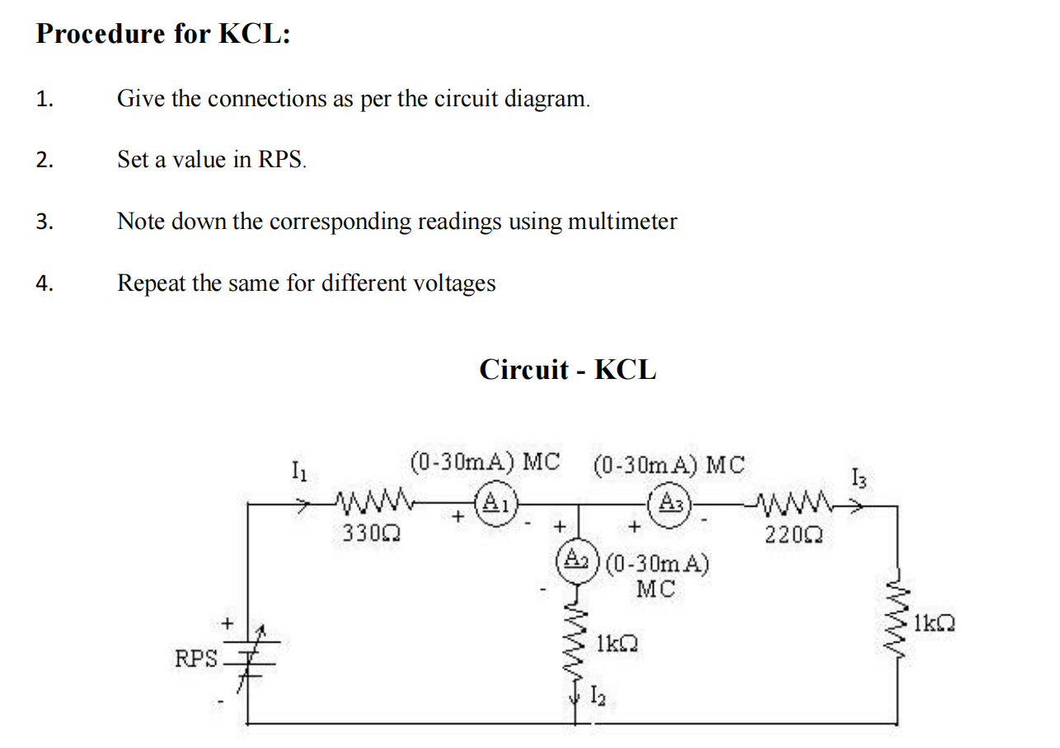
Circuit:
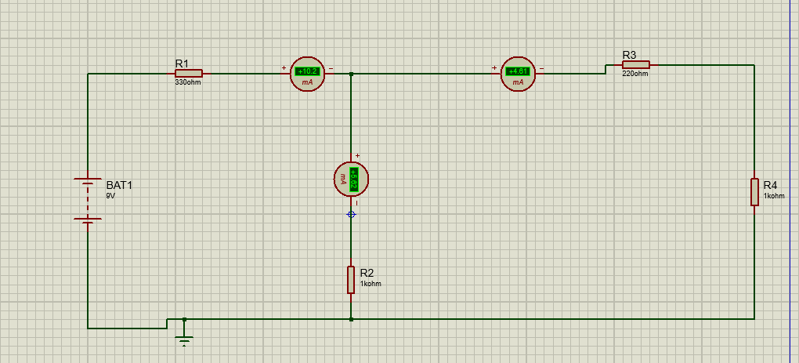
Explanation:

Step 1: Pick the Components
Search for these in the Component Mode (P):
VSOURCE or BATTERY: This will be your RPS (Regulated Power Supply).
RES: You will need three resistors.
DC Ammeter: To represent A1, A2, and A3 (found in Instruments Mode).

Step 2: Component Configuration
Set the values according to your diagram:
RPS: Set to a standard voltage (e.g., 10V or 12V) since it's variable.
Resistor 1 (Top Left): 330Ohm
Resistor 2 (Middle Vertical): 1kohm
Resistor 3 (Top Right): 220ohm
Resistor 4 (Right Vertical): 1kohm

Step 3: Circuit Assembly
Connect them exactly as shown in the image:
Main Branch: Connect the positive terminal of the RPS to the 330ohm resistor.
Ammeter A1: Place this in series right after the 330ohm resistor.
The Junction (Node): After A1, the wire splits into two directions (downwards and right).
Ammeter A2: Place this in the downward path, followed by the middle 1kohm resistor.
Ammeter A3: Place this in the rightward path, followed by the 220ohm and the last 1kohm resistor.

Step 4: Instrument Settings
Since your diagram specifies (0-30mA):
Right-click each DC Ammeter.
Select Edit Properties.
Change the Display Range to Milliamps (mA).
Ensure the polarity (+/-) of the ammeter matches your diagram so you don't get negative readings.

Table:
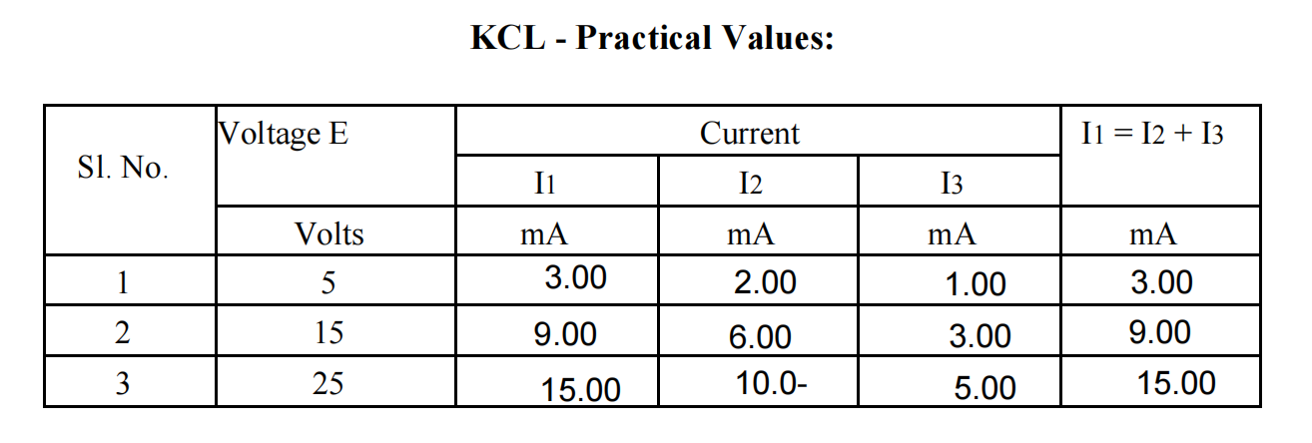
Task 2:
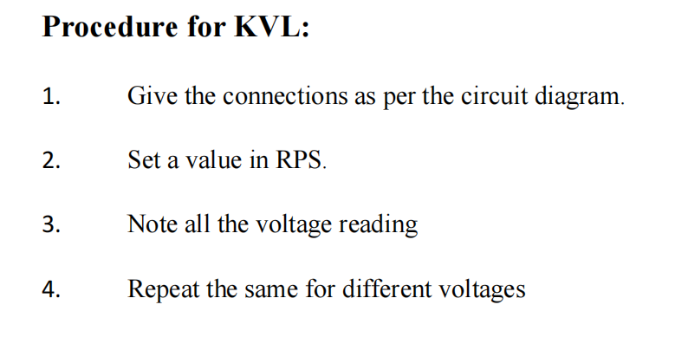
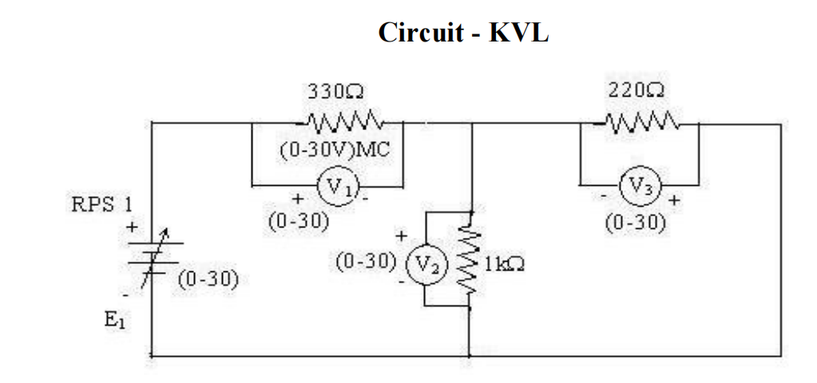

Circuit:
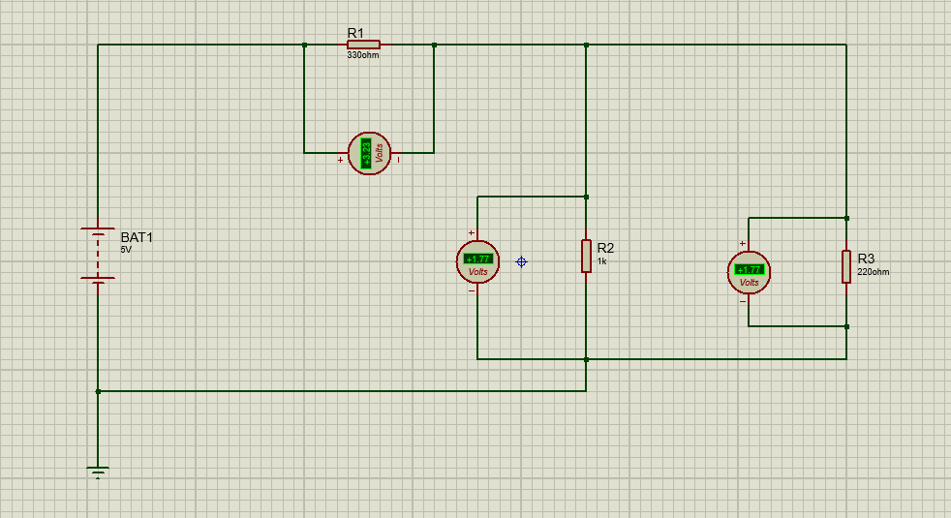
Explanation:
This is a Kirchhoff’s Voltage Law (KVL) circuit. To simulate this in Proteus and verify that the sum of voltages around a loop is zero, follow these steps:

Step 1: Pick the Components
Open the Component Mode (P) and select:
VSOURCE or BATTERY: For the RPS (Regulated Power Supply E1).
RES: You need three resistors.
DC Voltmeter: To represent V1, V2, and V3 (found in Instruments Mode).

Step 2: Component Configuration
Set the values based on your diagram:
RPS (E1): Set this to a value within the (0-30V) range, for example, 20V.
Resistor 1 (Top Left): 330ohm
Resistor 2 (Middle Vertical): 1kohm (1000ohm)
Resistor 3 (Top Right): 220ohm

Step 3: Circuit Assembly
Connect the components to form two loops:
Left Loop: Connect the RPS in series with the 330kohm resistor and the middle 1kohm resistor.
Right Loop: The 1kohm resistor is shared. Connect the 220kohm resistor in parallel to the 1kohm branch (forming a loop on the right).

Step 4: Voltmeter Placement (Crucial for KVL)
Voltmeters must be connected in parallel with each component. Pay close attention to the polarity (+ and -) shown in your image:
V1: Connect across the 330ohm resistor.
V2: Connect across the 1kohm resistor.
V3: Connect across the 220ohm resistor.
Table:
